Name: ARYEE RICHARD NII AYITEY
Index Number: 3614918
Course: MME 473: SHIP MACHINERY SYSTEM DESIGN.
ASSIGNMENT/ MID SEMESTER EXAMS.
QUESTION 1
What is the advantage of case hardening, how is it done, and give an example of a component which may have this treatment? Explain the difference between “strength and stiffness” of steel. Discuss the importance of these properties in shipboard structural members and machinery components.
Case Hardening
This is a heat treatment process where the chemical properties of a metal (usually steel) surface are changed and hardened (i.e., reinforced) by adding a thin layer of another metal alloy to the parts. The primary reason for such is to help extend the life (i.e., durability) of the steel by making it more resistant to abrasion and direct impacts because of an increase in strength and toughness. It is sometimes referred to as surface hardening. This technique is particularly significant for manufacture of carbon steel forging, carbon steel pinions and machine parts that are subject to high pressures and sharp impacts. Case hardened steel is formed by altering the chemical composition of the surface prior to/or after quenching and tempering. Altering the chemical composition can be done by the introduction of some elements such as carbon, nitrogen, cyanide and boron.
Carburizing: carbon is diffused into the part’s surface to a controlled depth by heating it within a temperature range of 1550-1750F (843-954C) in a carbonaceous medium. The case depth depends on carbon potential of medium used, and time and temperature of treatment. 3 types of carburizing are most often used; Liquid carburizing(using molten barium cyanide/sodium cyanide), gas carburizing (using a gas of controlled carbon content) and pack carburizing (sealing both steel and solid carbonaceous material in gas-tight container). Low carbon content steels (usually <0.3%) are used.
Nitriding: nitrogen is diffused into the part’s surface by heating within a temperature range of 900-1150F (482-621C) in an atmosphere of ammonia gas and dissociated ammonia for an extended period of time depending on the case depth desired. A thin, very hard case results from formation of nitrides.
Cyaniding: This process involves heating the part in a bath of sodium cyanide(liquid) to a temperature slightly above the transformation range, followed by quenching, to obtain a thin case of high hardness. Its temperature range is 1600-1749F (871-954C)
Boriding: is a case hardening diffusion process where boron atoms are diffused into the surface of a metal component. This forms hard, metal-boride compound layers under the surface of a component. This is also referred to as the Boronizing heat treatment. Its temperature range is 1300-1830F (704-999C).
Case hardening is suitable both for carbon and alloy steels, and typically mild steels are used. Not only does case hardening protect the mating surfaces (teeth) of these components during contact, but it also provides protection against sudden shock loads while helping to extend fatigue life. One example of a component is the engine camshaft (as shown below).
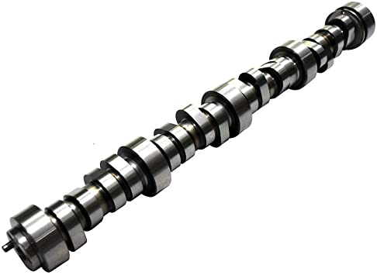
Stiffness of a material is the resistance to deflection whereas the strength of that same material is a measure of stress that can be applied before permanently deformation. The stiffness of steel relates to how it bends under load while still returning to its original shape once load is removed and the strength of steel refers to the deformation and fracture performance of steel under action of external force. The strength of steel includes tensile strength, bending strength and compressive strength
A ship hull, of whatever materials it may be made, must be strong enough to withstand all the loads that may be imposed upon it by normal service and by any seaway that may be expected during its life. A ship structure is sufficiently strong if it can support all the fixed loads of its machinery, fittings and equipment, and all the cargo loads, and if it can withstand without permanent change of shape, cracking, and fracture all the hydrostatic and hydrodynamic loads which can be imposed upon it in calm water or in any kind of seaway in which it is supposed to operate. It is sufficiently stiff if, under any of these service loads, it does not flex or deform unduly so as to interfere with the alignment of operation of machinery or with any other function, major or minor.
Vibratory motion can build up to unacceptable peaks if local portions of the structure are in resonance with the periodic applied forces. It is customary in ship structures and ship components to limit the calculated stresses under the heaviest contemplated service loading to a certain fraction of the limiting stress for the material being used at which permanent change of shape or damage will occur. The margin thus provided takes care of unusual and emergency conditions which rarely can be foreseen at the time of design.

QUESTION 2
Explain how the crankshaft of an engine is subject to combined bending, twisting and direct loading.
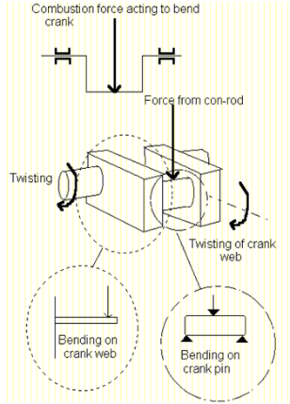
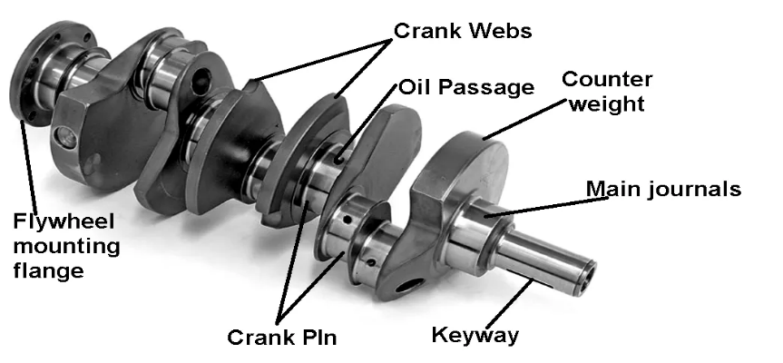
The crankshaft is a moving part of the internal combustion engine (ICE). Its main function is to transform the linear motion of the piston into rotational motion. The pistons are connected to the crankshaft through the connecting rods. The crankshaft is mounted within the engine block. An engine is any device/machine that converts chemical energy to thermal energy to produce mechanical power.
Engine speed is primarily dependent on crankshaft revolutions per cycle which generates some kinetic energy. The faster an engine runs, the more complete crankshaft revolutions per time and the more power it produces. Whenever, the engine comes to a sudden stop all the kinetic energy is dissipated mainly through the crankshaft first before any other auxiliary component. When the impact initially occurs, the crankshaft will twist. With the combination of the crankshaft twisting and the distance between the bottom of the engine and the lower end of the crankshaft acting like a lever, enough torque is created to bend the crankshaft. Bending results in the tensile, compressive and shear stresses in the material of the crank web.
The crankshaft has a linear axis about which it rotates, typically with several bearing journals riding on replaceable bearings (the main bearings) held in the engine block. As the crankshaft undergoes a great deal of sideways load from each cylinder in a multicylinder engine, it must be supported by several such bearings, not just one at each end. The shaft is subjected to various forces but generally needs to be analysed in two positions. Firstly, failure may occur at the position of maximum bending; this may be at the centre of the crank or at either end. In such a condition the failure is due to bending and the pressure in the cylinder is maximal. Second, the crank may fail due to twisting, so the conrod needs to be checked for shear at the position of maximal twisting. The pressure at this position is the maximal pressure, but only a fraction of maximal pressure. Crankshafts are subject to a complex form of the loading which varies with time. In addition, shrink fits, oil holes & fillet radii add to the complexity.
Gas loads on the crankpin which produce alternating tangential bending of the webs alternating bending of the crankpin & elements of shearing of the crankpin at the inner web faces
Torsional vibrations produce alternating twisting of the crankshaft, the journal of which is in any event torsionally loaded by the gas loads via the web
Axial vibrations in conjunction with the alternating lengthening & shortening of the shaft combined with local bending. Crankshafts may, in addition be subject to misalignment due to bearing wear or poor chocking. This produces & alternating bending of the crankshaft
Crankshaft is subjected to cyclic bending and torsional loads due to the gas pressure and inertial forces. Due to these forces, crankshaft is subjected to bending and torsional stresses with high stress concentration at the crankpin fillet and journal bearing fillet. When Crank is at Dead Center: the maximum gas pressure on the piston will transmit maximum force on the crankpin in the plane of the crank causing only bending of the shaft. The crankpin ends of the crankshaft will only be subjected to bending moment. Thus, when crank is at dead center, the bending moment on the shaft is maximum. Crankpin is also subjected to shear stress due to twisting moment. When the crank is at an angle of maximum twisting moment; the twisting moment on the crankshaft will be maximum. The crankshaft material must have a built-in resistance, which is of the equal importance to its U.T.S. (Ultimate Tensile Strength). Mild steel is usually the material used but, in some cases, alloying the steel with a small percentage of the Ni, Cr, Vanadium may take place.

